
Shaheed Zulfikar Ali Bhutto Institute of Science &
Technology

COMPUTER SCIENCE DEPARTMENT


SHAHEED ZULFIKHAR ALI BHUTTO INSTITUTE
OF SCIENCE & TECHNOLOGY
SOFTWARE ENGINEERING DEPARTMENT

Total Marks:_______

Obtained Marks:_____

BS-SE-6A

Web Engineering

Assignment #05

Submitted To: Muhammad Abuzar
_____________________________________________________________________________________________________________________________________________________________________________________________________________________________________

Web Engineering SZABIST-ISB

Shaheed Zulfikar Ali Bhutto Institute of Science &
Technology

COMPUTER SCIENCE DEPARTMENT

Student Name: Zainab Fatima
______________________________________________________________________________________________________________________________________________________________________________________________________________________________________
Reg. Number: 2280287_____________________________________________________________________________________________________________________________ _________________________________________________________________________________________________________

Question:
Develop a Laravel application that includes a user registration feature where users can submit their Username, Email,Password and Gender.
- When the form is submitted, the entered data should be stored in the database. The application must update the page dynamically to display the newly added user information without reloading the page.
- Additionally, provide a separate document explaining the controller logic step by step, clearly describing the role of each method and how data is processed.

ANSWER:

STEP 1:
Create Laravel Project

- First, a new Laravel project was created using the Composer command in the terminal.
- Laravel provided the basic folder structure, files, and configuration needed to build the web application.

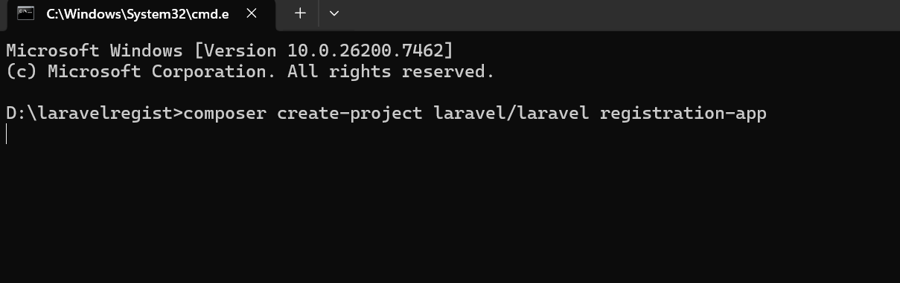
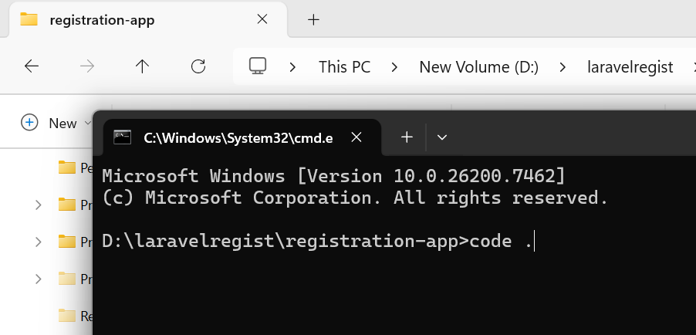
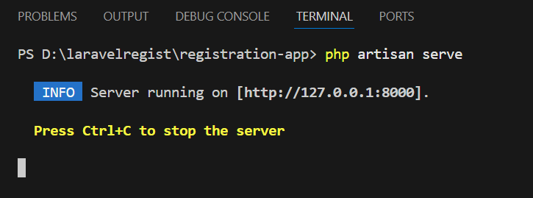

STEP 2:
Database Configuration
- After creating the project, the database configuration was done in the .env file.
- The database name, username, password, and port number were set so that Laravel could connect to MySQL properly.

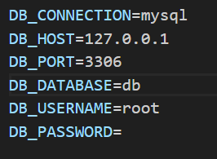

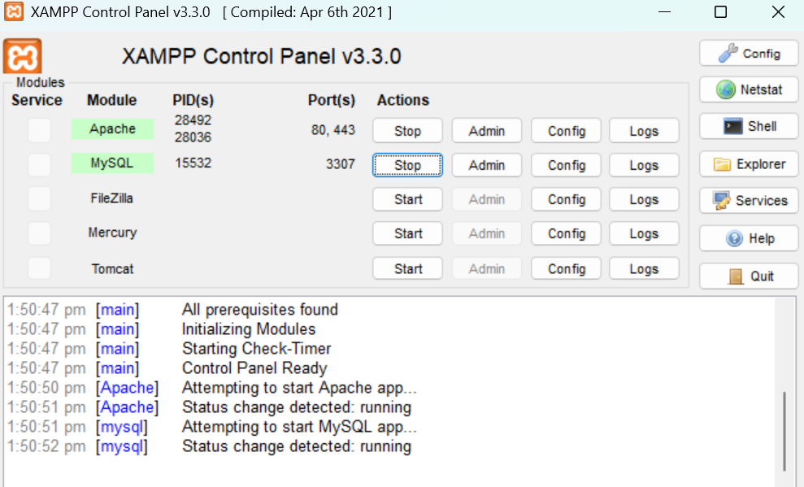

STEP 3:
Create Database in phpMyAdmin

A new database named userdb was created using phpMyAdmin.
This database is used to store all user registration records.
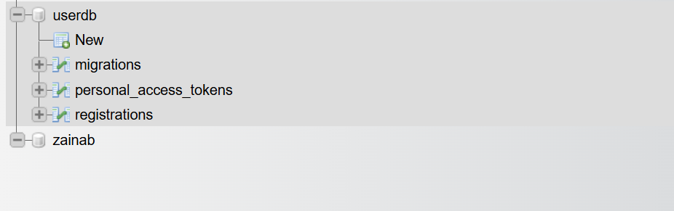

STEP 4:
Create Migration for Registration Table
A migration file was created to define the structure of the database table.
The table was designed to store the following user information:
- Username
- Email
- Password
- Gender

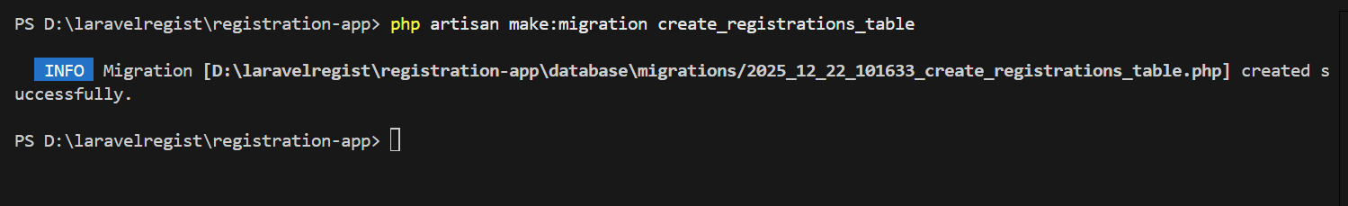
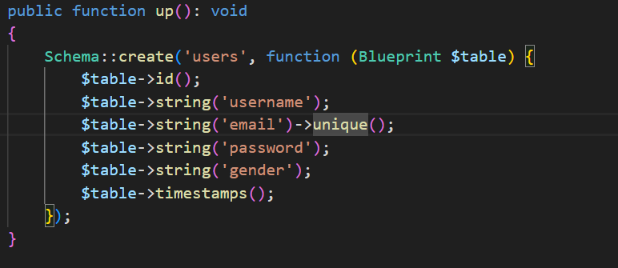

STEP 5:
Run Migration

- The migration command was executed using Artisan.
- This command created the registrations table inside the database automatically.

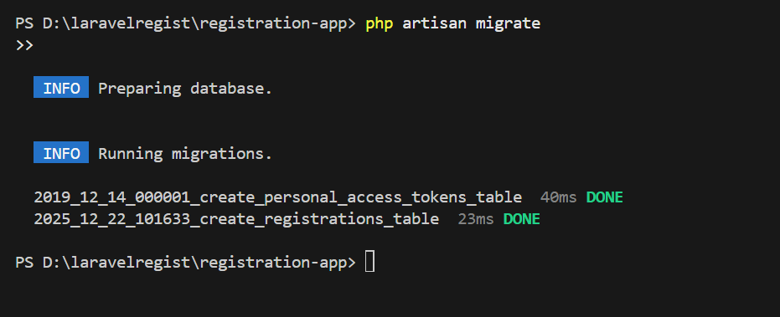

STEP 6:
Create Model

- A model named Registration was created.
- This model represents the registrations table and is used to insert and manage data in the database.
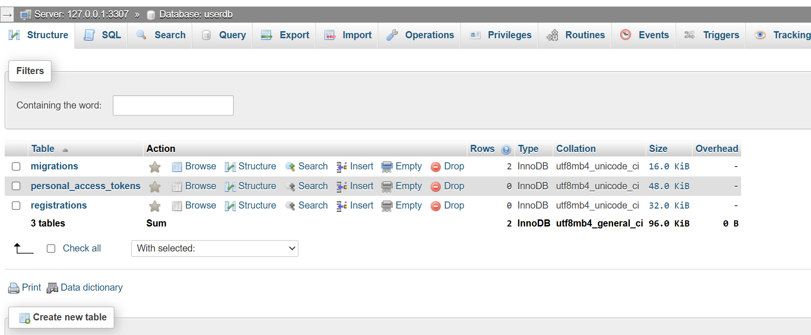
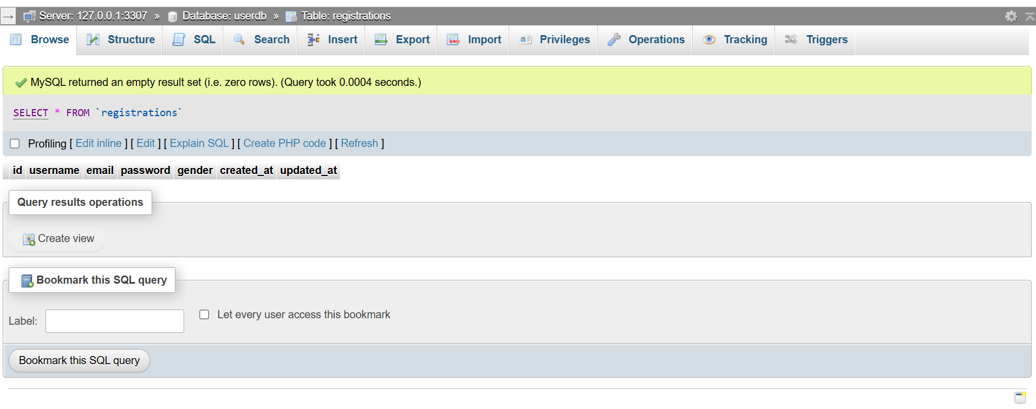

STEP 7:
Create Controller

- A controller named RegistrationController was created.
- The controller is responsible for receiving form data and processing it before saving it to the database.

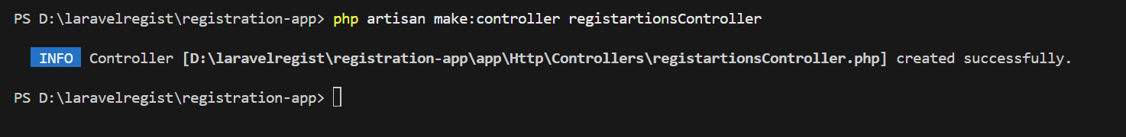
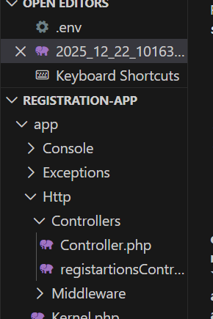

STEP 8:
Controller Logic as store method
Inside the RegistrationController, a method named store() was created.
This method performs the following actions:
- Receives user input from the registration form
- Encrypts the password for security
- Stores the data in the database using the Registration model
- Returns a response to the AJAX request

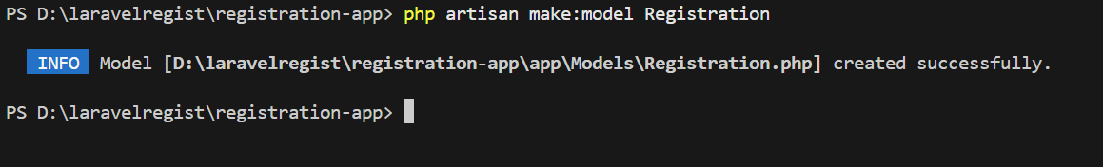
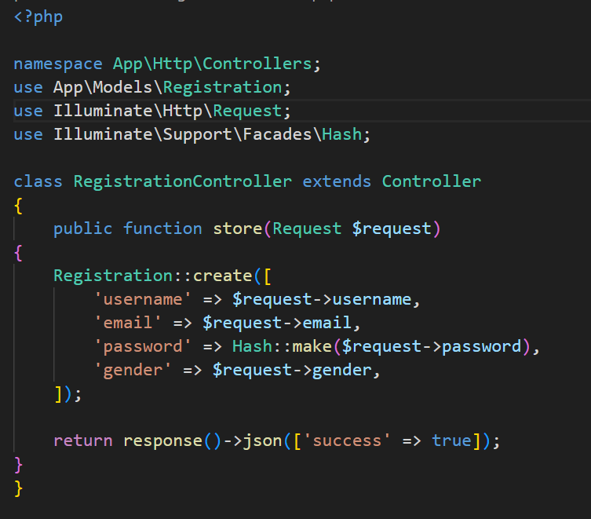

STEP 9:
Create Registration Form using Blade File
A Blade view file named registration.blade.php was created.
This file contains the registration form with the following fields:
- Username
- Email
- Password
- Gender
- Submit button
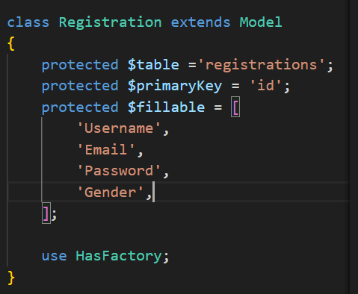

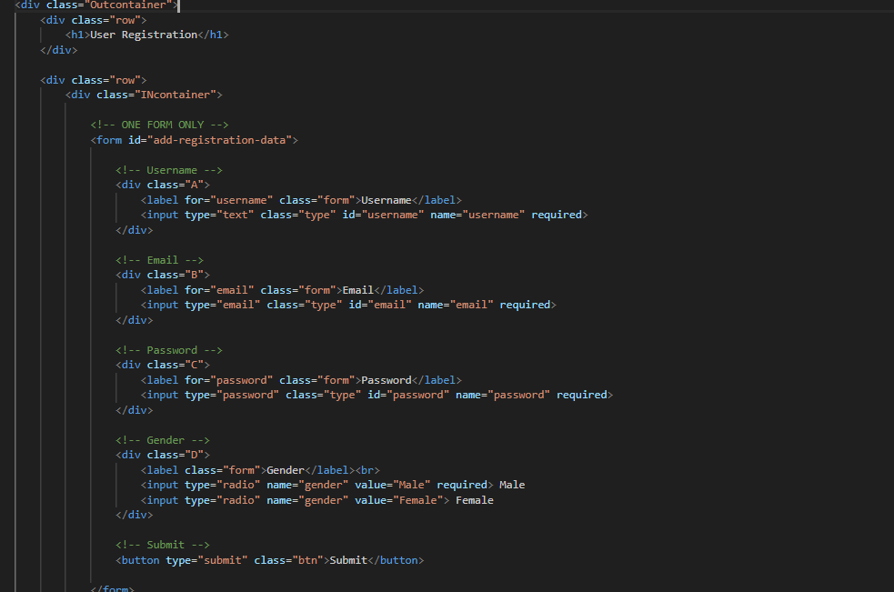
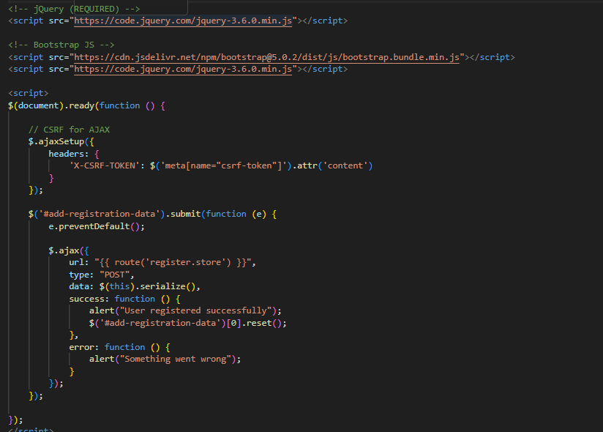

STEP 10:
Define Routes (web.php)

Routes were defined in the web.php file:
- A GET route to display the registration form
- A POST route to send form data to the controller
These routes connect the form with the controller logic.
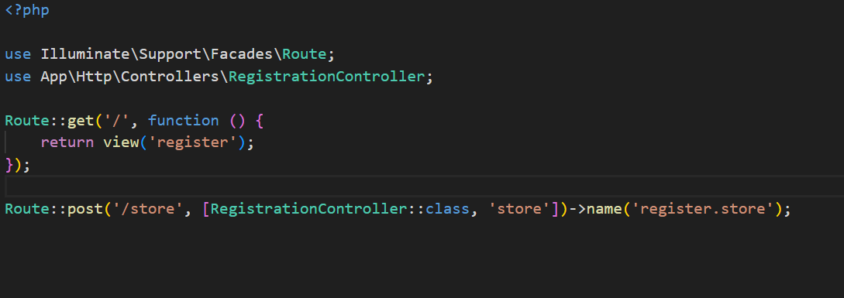
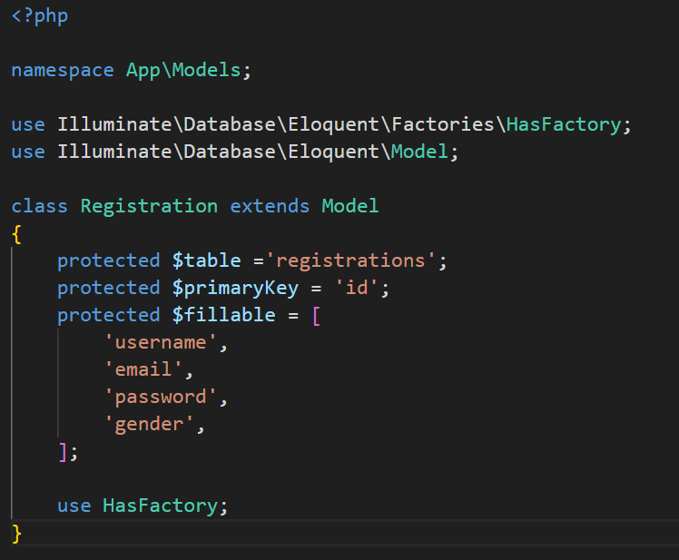

STEP 11:
Use AJAX for Dynamic Form Submission

AJAX was used to submit the registration form without reloading the page.
When the user clicks the Submit button:
- The page does not refresh
- Data is sent to the controller in the background
- A success message is shown after saving data

STEP 12:
Run Laravel Application

- The Laravel development server was started using the Artisan command.
- The application was accessed in the browser using:
http://127.0.0.1:8000

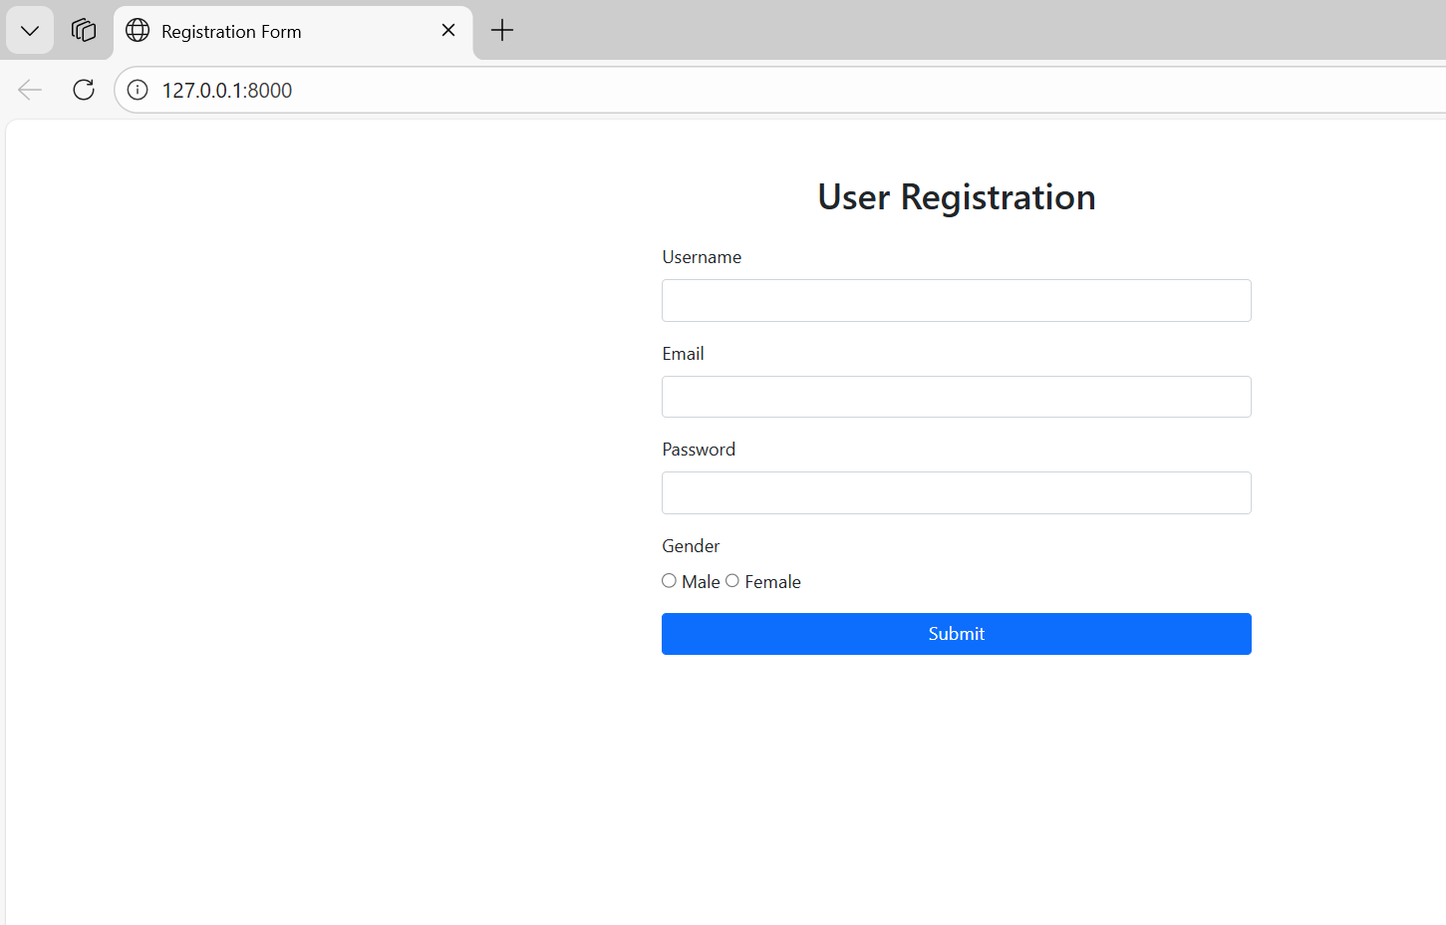

STEP 13:
Test User Registration

- The registration form was filled with user data and submitted.
- A success alert message appeared, confirming that the data was saved successfully.

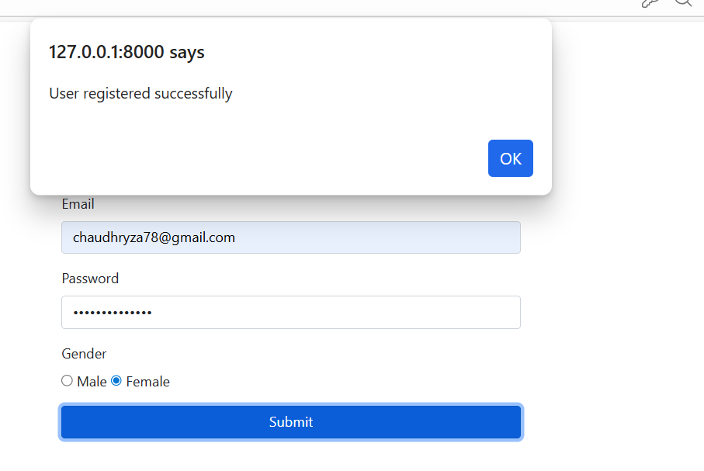

STEP 14:
Verify Data in Database

- Finally, phpMyAdmin was opened to verify the stored data.
- The new user record appeared in the registrations table, confirming that the registration process worked correctly.

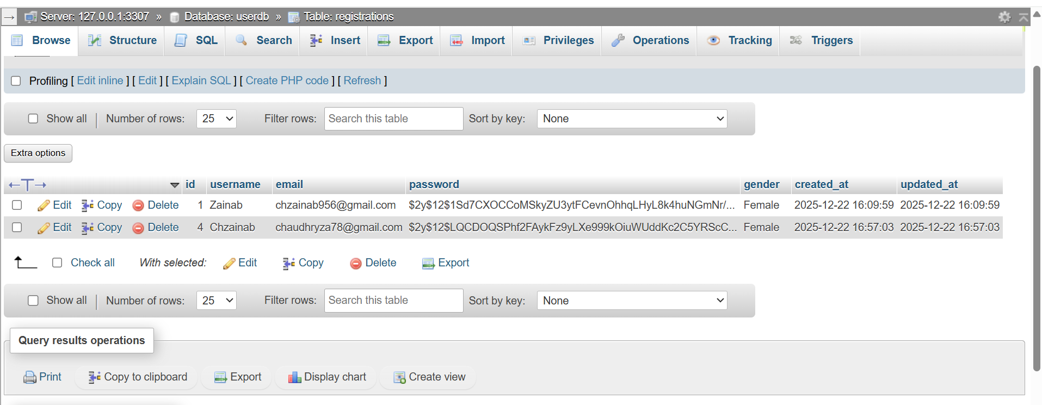

Controller::
- RegistrationController handles user requests.
- It receives form data, processes it, encrypts the password, stores the data in the database, and sends a response back to AJAX.

Model::
- Registration Model represents the database table.
- It allows Laravel to insert user data into the registrations table in a simple and secure way.

Web Engineering SZABIST-ISB

